Project Design Phase
AI FitTrack – Solution Architecture
Date | 24 September 2026
Team ID | SWTID-2026-9501
Project Name | AI FitTrack – AI-Powered Fitness Tracking System
Maximum Marks | 4 Marks
Solution Architecture:
AI FitTrack solution architecture bridges fitness product requirements and the technical implementation. It defines structure, responsibilities, security boundaries and data flows for React, Express, MongoDB Atlas and Gemini.
- Select a practical technology set for a secure, maintainable and AI-enabled fitness application.
- Describe structure, characteristics, behavior and integration points for project stakeholders.
- Define features, development phases and API requirements.
- Provide implementation specifications for client, API, database and AI integration.
AI FitTrack Solution Architecture Diagram:

Figure 1: Modern AI FitTrack architecture and request flow
Architecture Layers
• Presentation: React client and CSS UI.
• API Gateway: Express server and REST routes.
• Security: JWT middleware, bcryptjs and Helmet.
• Business Logic: controllers and dashboard calculations.
• Integration: Gemini service for AI generation.
• Persistence: Mongoose models backed by MongoDB Atlas.
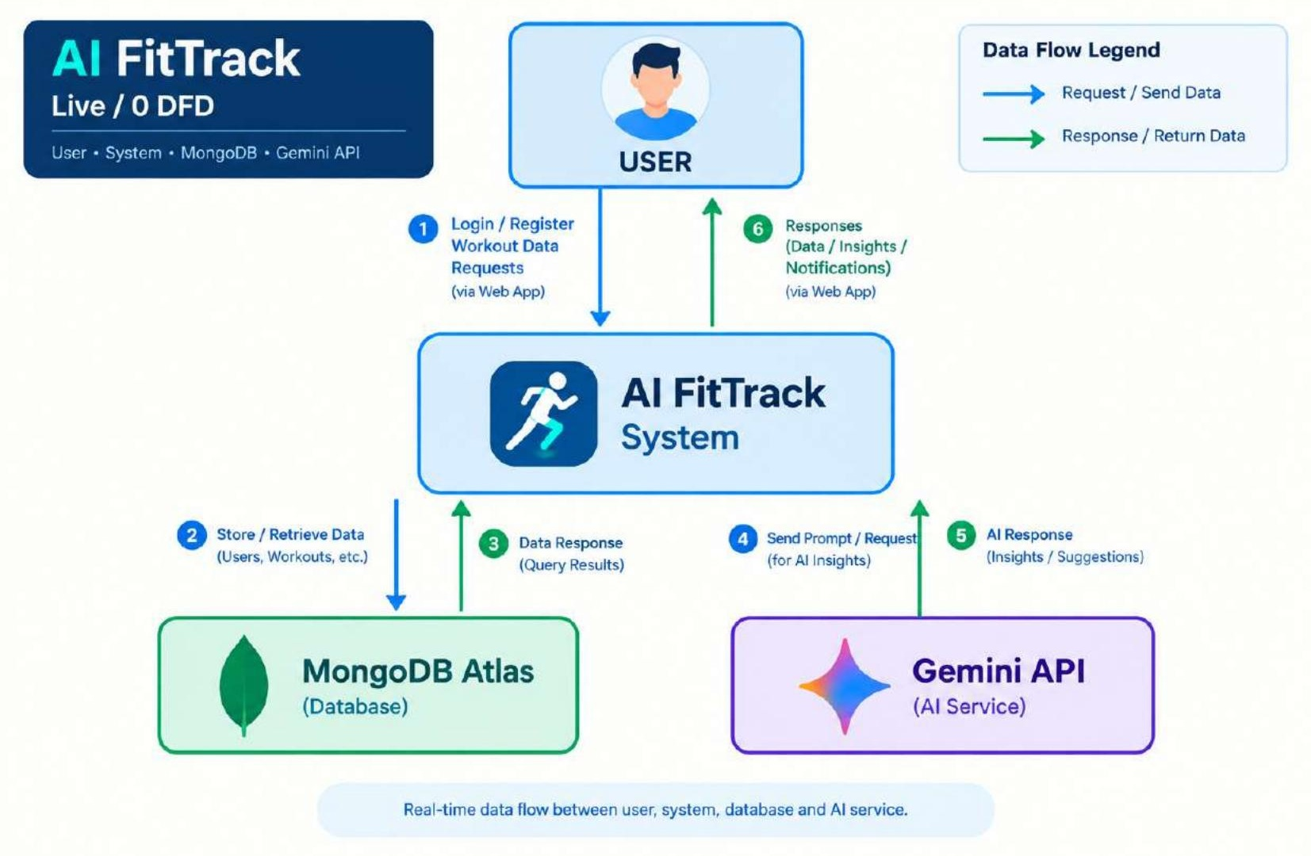
Request & Data Flow
A protected request enters the Express API, passes authentication middleware, reaches the relevant controller, and then uses a model or service. Workout data is scoped to the authenticated user. AI requests pass through the Gemini service and return controlled JSON.

